**Project Title:** *Taste Haven – Restaurant Landing Page*

**Submitted By:**

* Savio Nazareth

2462362

savio.john@btech.christuniversity.in

* Tenzin Rigzin

2460462

Tenzin.rigzin@btech.christuniversity.in

* Shamith Gowda

2462530

shamith.m@btech.christuniversity.in

**Course:** Web Design Fundamentals  
 **Instructor Name:** Narendra Kumar  
 **Institution:** Christ UNiversity  
 **Date of Submission:** 11/08/2025

## **2. Abstract**

This project involves the design and development of a visually appealing one-page restaurant landing website named *Taste Haven* using only HTML and CSS. The goal was to create an engaging platform to showcase the restaurant’s menu, share information about its story, and provide contact details. The design incorporates structured semantic HTML, consistent image sizing, and clean layouts. CSS Flexbox was used for alignment, ensuring a visually cohesive look across all sections. The final outcome is a well-structured, aesthetically pleasing, and user-friendly restaurant landing page that can be adapted for real-world dining businesses.

## **3. Objectives**

* Design a visually appealing restaurant landing page following modern UI/UX design principles.
* Use semantic HTML5 elements for well-structured content.
* Implement consistent image dimensions and alignment for a clean presentation.
* Apply CSS Flexbox for responsive and organized layouts.
* Create distinct sections for Menu, About Us, and Contact information.

## **4. Scope of the Project**

* Focused solely on **front-end design**.
* No JavaScript or backend functionality implemented.
* Designed for desktop and tablet screens (mobile responsiveness can be enhanced).
* Built entirely with open-source tools and pure HTML & CSS without frameworks.

## **5. Tools & Technologies Used**

|  |  |
| --- | --- |
| **Tool/Technology** | **Purpose** |
| HTML5 | Content structure and semantic markup |
| CSS3 | Styling, layout, and formatting |
| VS Code | Code editor |
| Chrome DevTools | Testing, debugging, and layout adjustments |

## **6. HTML Structure Overview**

* Used semantic tags: <header>, <nav>, <section>, <footer>.
* Sections include: **Hero**, **Menu**, **About Us**, **Contact**, **Footer**.
* Navigation links use anchor tags for quick jumps to sections.
* Images are placed within descriptive <div> containers for structure.

## **7. CSS Styling Strategy**

* Inline <style> tag for quick layout adjustments, external stylesheet for main styling (style.css).
* Used **Flexbox** for arranging menu items and aligning about section content.
* Applied fixed image sizes (200px × 250px) with object-fit: cover.
* Included spacing (margin and gap) for better visual separation.

## **8. Key Features**

|  |  |
| --- | --- |
| **Feature** | **Description** |
| Consistent Image Size | All menu images have uniform dimensions for a clean look. |
| Sectioned Layout | Clearly separated Menu, About, and Contact sections. |
| Flexbox Alignment | Items neatly aligned for visual harmony. |
| Contact Information | Includes location, phone, and working hours with icons. |
| Social Media Links | Integrated social icons in footer. |

## **9. Challenges Faced & Solutions**

|  |  |
| --- | --- |
| **Challenge** | **Solution** |
| Inconsistent image sizes | Used fixed width and height with object-fit: cover. |
| Aligning text and images side-by-side | Implemented CSS Flexbox with gap for spacing. |
| Maintaining section consistency | Created uniform padding and margin for all sections. |

## **10. Outcome**

* A clean, structured, and visually appealing restaurant landing page was developed.
* The page highlights the restaurant’s offerings, story, and contact details in a user-friendly format.
* Learned how to manage consistent image presentation and structured layouts effectively using CSS.

## **11. Future Enhancements**

* Add mobile responsiveness with media queries.
* Implement JavaScript for interactivity (e.g., menu filtering, form validation).
* Include animations for smooth scrolling and hover effects.
* Backend integration for newsletter subscription.

12. Sample Code

<section id="menu">

<h2>Our Menu</h2>

<div class="menu-grid">

<div class="menu-category">

<h3>Starters</h3>

<div class="menu-item">

<img src="bruschetta.jpg" alt="Bruschetta">

<p>Bruschetta</p>

</div>

</div>

</div>

</section>

**13. Screenshots of Final Output**

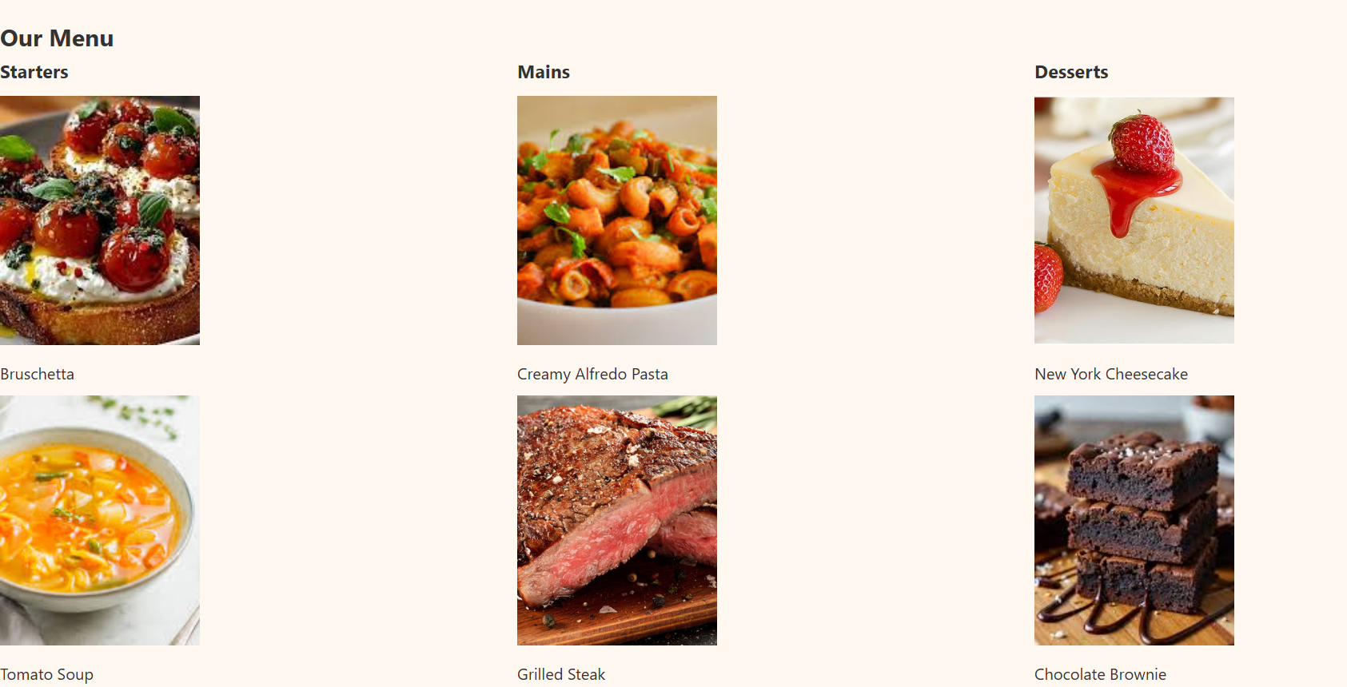

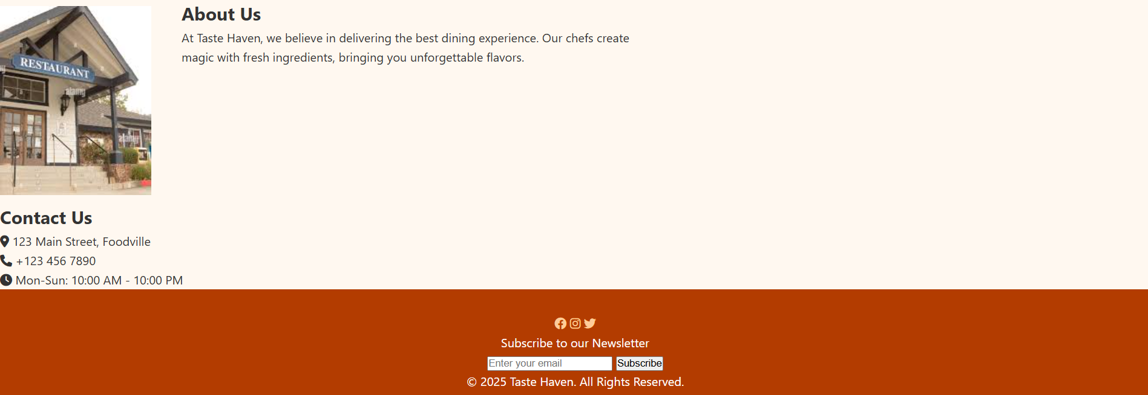

## **14. Conclusion**

This project successfully demonstrates the creation of a functional and attractive restaurant landing page using only HTML and CSS. The work enhanced practical skills in layout design, semantic markup, and CSS styling. The resulting site provides a solid foundation for further development into a fully responsive and interactive online restaurant presence.

## **15. References**

* L&T LMS : <https://learn.lntedutech.com/Landing/MyCourse>
* W3Schools HTML & CSS Documentation
* Font Awesome Icon Library